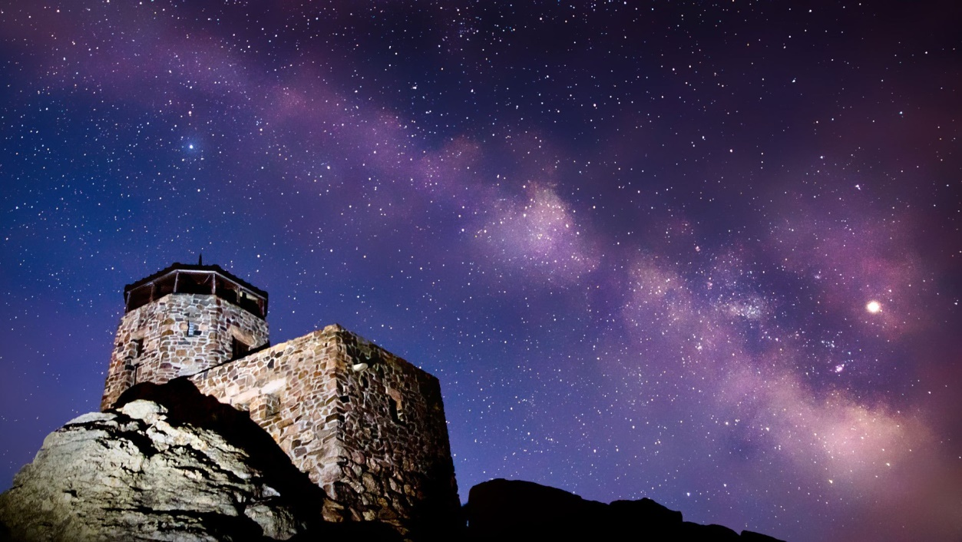

**Outdoor Fun in South Dakota**

In this modern time, not just kids, but everyone needs some fresh air and to plug out. We are constantly on our computers and cell phones, so we forget how important is to go outside and spend a little bit of time in nature. There are plenty of places you can visit and refill your batteries that will for sure make you feel ready to make new goals in life.

Climbing rock, riding a bike, hiking are some of the activities you can do that will also benefit you in health. South Dakota is full of places you can visit and have a great time. For some of them, you should have certain equipment, so you should inform yourself before going on a trip. [South Dakota outdoor travel](http://www.sdoutdoorexpo.com) can be a great choice to relieve stress and also have fun.

**Badlands Stargaze**

The National Park Badlands is a mysterious landscape enclosed by grassland. When the night comes, you can see the Milky Way spread over the southern sky for a really outstanding experience. When July comes, the Badlands Astronomy Festival is being hosted by National Park Service, where with a high power telescope you can view the beautiful night sky and also you can hear a lot of interesting stuff about starts from astronomers or people that love that field of study.

Throughout the summer months on the weekend, there is a summer sky observing program. It is a great experience for kids and everyone who is going there for the first time.

Read more about it here: <http://www.travelasfamily.com/blog/tag/badlands-national-park/>

**Black Elk Peak**

At 2002 meters, the highest point on the Rocky Mountains is the Black Elk Peak located in the United States. Black Elk Peak is located in the Black Hills National Forest and it can brag about 100-mile views from its top.

The old stone fire tower is the perfect location where you can see the whole place from. There are many paths that will take you to the top, most in the range of 5 to 7 miles round trip. Wisely choose which route you will go, and be sure you bring everything you need for the trip. You should always go with someone experienced, so you won't get lost.

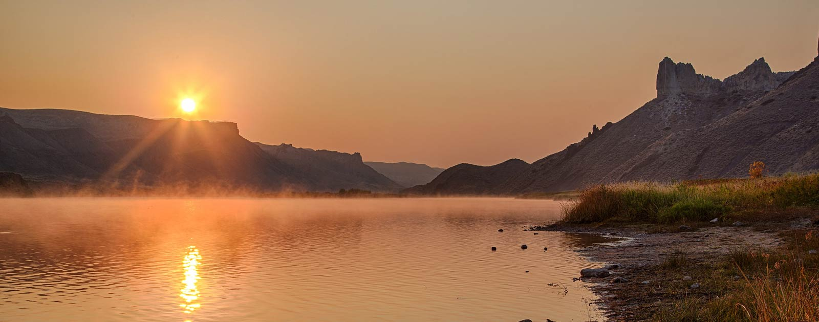

**Missouri River**

If you are more attracted to water sports, the Missouri River is a great place for paddling and just enjoying the longest river in the US. The state is divided into two regions by the river, also known as the east river and west river side.

You can have a lot of fun downstream the big river and also there is a pleasant mix of free-flowing reservoirs and current you can paddle through. If you don't feel like paddling you can always set a camp. You can go hiking nearby or just go on a fishing trip. All in all, there is a lot to see on the Missouri River. Click [here](https://en.wikipedia.org/wiki/Missouri_River) to read more.

**Scuba diving**

Because South Dakota is in the middle of the country, many people think there aren't any aquatic adventures you can do, but that isn't the case because scuba diving in Landlocked State is a thing. The Lake Oahe, Sheridan Lake, and the Pactola Reservoir are very famous diving spots.

Something you aren't doing every day is getting up close to lake animals like the variety of fish, turtles, and frogs. There is also an option to get to the bottom of Pactola and see the remains of a town that was in the same spot. There are dive shops all around, so you can easily find a tour guide or if you are experienced, just rent the equipment.

**Agate hunting**

For those who like an adventure or something similar to treasure hunting, hunting for Fairburn Agate in Badlands is a perfect choice. They are very colorful stones that can also be sold or you can get someone to make your jewelry.

You can also find other gemstones, but [Fairburn Agate](https://blackhillsvisitor.com/see-and-do/hunting-fairburn-agates/) is the symbol of this place. There are a lot of spots where you can see people were looking for them, so always check markings on the ground and rocks. The adrenaline rush when you find a gemstone is an experience you need to have.